Name: Isma Saleem
Roll no : 2024-CET-7
Class: BS CET
Semester : 4th
Subject: Graphic designing
Exam: Lab Mid
Submitted to: Engr Ahmed khawaja

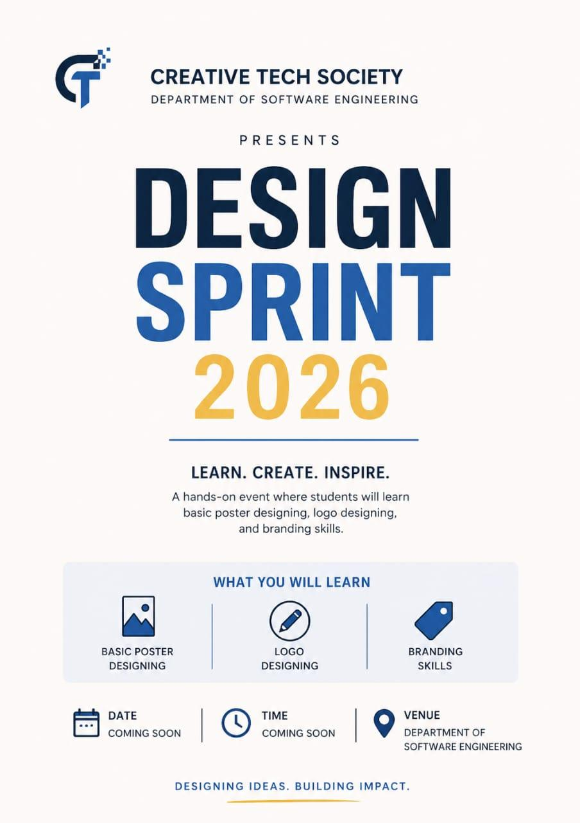

Introduction:
Design Sprint 2026 is a practical event organized by the Creative Tech Society, Department of Software Engineering. It focuses on teaching students creative design techniques through hands-on activities.

Procedure:
Participants are guided through basic design principles. They practice creating posters and logos, and learn how branding works. Activities are performed using simple design tools.

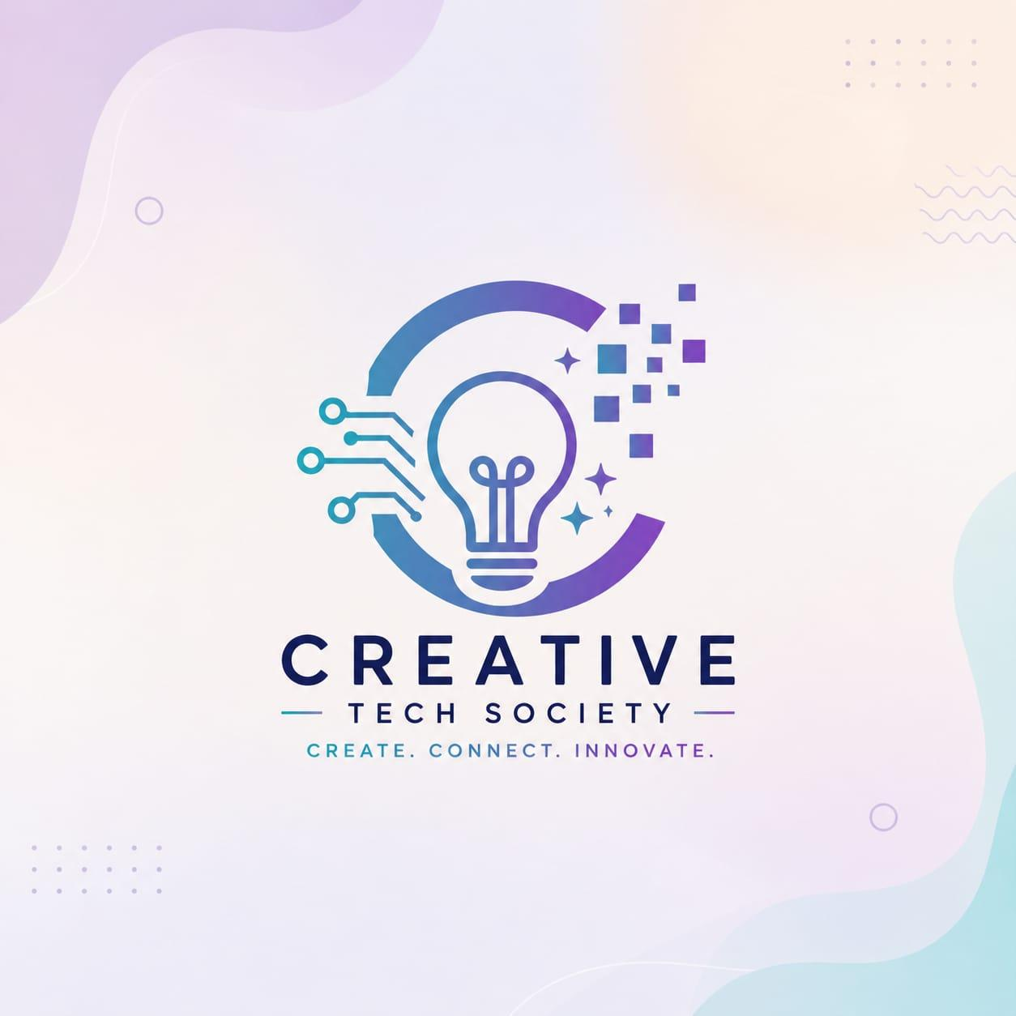

Creative Tech Society Logo

1. Introduction

This report explains the complete design process of the Creative Tech Society logo. The logo represents innovation, creativity, and modern technology using a clean and professional visual style.

. Concept Development.
The logo is based on the combination of:

- Light Bulb → Represents ideas, creativity, innovation
- Circuit Lines → Represents technology and digital systems
- Pixel Squares → Represents digital transformation and future growth
- Circular Shape → Symbolizes unity, continuity, and society.

.Design Elements
4.1 Symbol/Icon

- A light bulb is placed in the center to show ideas.
- The left side includes circuit-style lines to show tech connection.
- The right side has pixel blocks fading out, representing digital evolution.
- A semi-circle ring surrounds the bulb to give a complete modern look.

. Color Scheme
The logo uses a gradient color palette:
- Blue → Trust, intelligence, technology
- Purple → Creativity, innovation
- Cyan/Teal → Freshness, modern digital feel

Style Used: Gradient (Blue → Purple)
.Typography (Fonts Used)
Main Title: "CREATIVE"
- Font Style: Sans-serif, Bold, Clean
- Suggested Font Matches:
- Montserrat Bold
- Poppins Bold
- Gotham (similar style)

Subtitle: "TECH SOCIETY"

- Font Style: Light / Medium Sans-serif
- Suggested Fonts:
- Montserrat Medium
- Open Sans
- Lato

Tagline: "Create. Connect. Innovate."

- Font Style: Light, spaced letters
- All caps with wide letter space

. Layout Structure

- Icon is placed on top
- Main title below icon
- Subtitle under main title
- Tagline at the bottom with spacing

This creates a balanced vertical hierarchy

. Design Principles Applied

- Balance: Symmetrical alignment
- Contrast: Light background vs dark text
- Hierarchy: Clear reading order
- Consistency: Same font family style
- Simplicity: Clean and minimal design

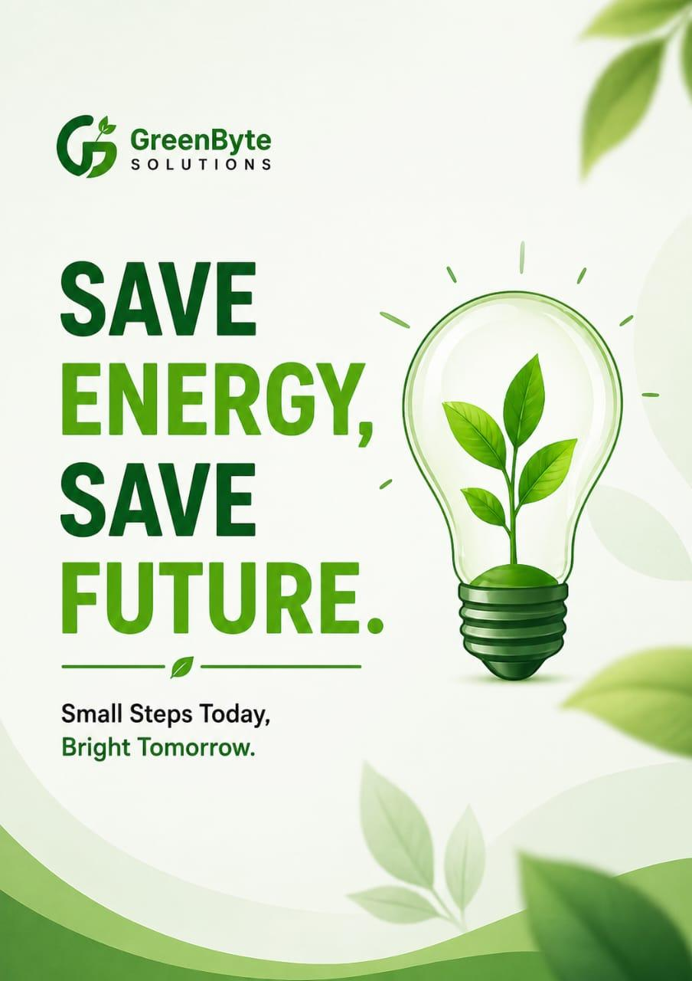

GreenByte Solutions – Awareness Campaign poster

1. Introduction

This report explains the complete design process of the “Save Energy, Save Future” awareness campaign poster. The poster is designed to promote environmental responsibility and encourage people to save energy for a better future.

2. Objective
The main objectives of this poster design are:
- To spread awareness about energy conservation
- To promote a green and eco-friendly lifestyle
- To deliver a clear and strong message through visual design
- To make the poster suitable for social media and print use

. Design Elements
4.1 Main Visual (Hero Image)
- A light bulb with a plant inside represents:
- Energy + Nature together
- Growth and sustainability
- Soil at the base shows real-life environmental connection.

.Supporting Graphics
- Green leaves → Nature and freshness
- Wind turbine → Renewable energy
- Birds and skyline → Clean and peaceful environment
- Icons at bottom → Easy understanding of key points

. Color Scheme
The poster uses a green-based color palette:
- Dark Green → Strength, stability
- Light Green → Freshness, environment
- White Background → Clean and modern look.

. Typography (Fonts Used)
Main Heading: “SAVE ENERGY, SAVE FUTURE”
- Font Style: Bold Sans-serif (Heavy Weight)
- Suggested Fonts:
- Montserrat Extra Bold
- Poppins Bold
- Font Style: Regular Sans-serif
- Clean and readable

. Layout Structure
- Top Section: Logo + Campaign title
- Center Left: Big bold message (main focus)
- Center Right: Visual (light bulb with plant)

